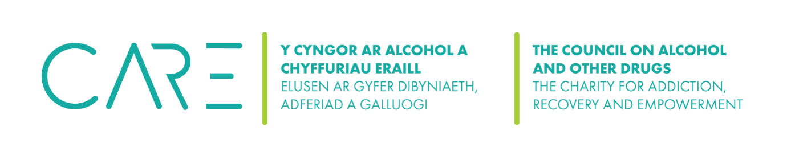

(CAOD) Safeguarding for Suicidal Ideation Documentation

By implementing this safeguarding document, the CAOD commits to providing a safe, supportive, and ethical environment for clients experiencing suicidal ideation, ensuring their well-being and dignity are upheld at all times. This document must be attached to the client’s file in accordance with our Suicide Risk Assessment and Safeguarding Procedures.

Administration Information
Client name
Client date of birth
Date of session
Counsellor name

Session Summary
Presenting issues
Counsellor’s direct enquiry of intention
Frequency of suicidal thoughts
Intensity of suicidal thoughts
How long do these thoughts last for?
Has the client formed a plan for suicide?
Is the client preparing to action their plan?
Does the client have the means to carry out their plan?
Level of the client’s intent (1 – 10)
Have there been previous attempts?

Risk Increase Factors (mark Y if applicable)
Recent life changes |  |  | Social isolation
Bereavement |  |  | Workplace stress
Substance abuse |  |  | Financial stress
Relationship issues |  |  | Family history of suicide
Past trauma |  |  | Gender issues
Mental health diagnosis |  |  | Bereavement
Chronic illness |  |  | Self-harm
Male |  |  | Domestic violence
Other (give details)

Safety Plan (mark Y/N)
Has a safety plan been discussed and agreed upon with the client?
Has the client been made aware of crisis and emergency helplines?
Has the client aware of our limitations for confidentially?
Does the client have a support system in place?
Additional details:

Action Taken (mark Y/N)
Notification to MAC Counselling & Wellbeing Clinical Director
Contact the client’s GP Practice
Contact the client’s emergency contact
Referral to mental health services
Additional details:

Follow-up
Next session booked for:
Arrangements of emails or calls between sessions:
Review of Safety Plan date:

Counsellor’s Notes

