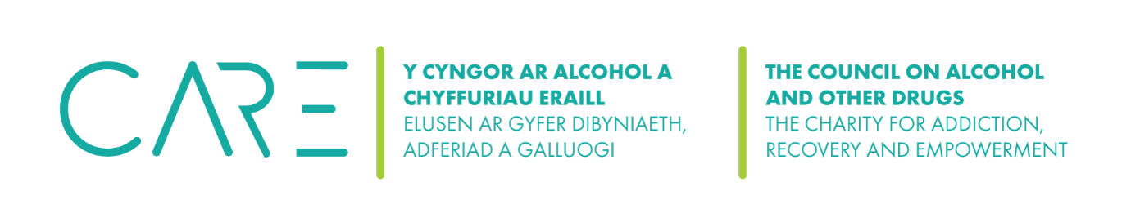
The Council on Alcohol and Other Drugs (CAOD): Trustee positions Automatic disqualification declaration

CAOD uses this alongside the existing trustee declaration form by:
- Satisfying ourselves that individuals who hold (or who are applying for) a trustee position are not disqualified from holding that position. CAOD asks the individual to complete this declaration alongside the existing trustee declaration form if they have not already done so.
- Individuals who hold, or are applying for, a trustee position, to declare that they are not disqualified from holding that position.
The Council on Alcohol and Other Drugs (CAOD) must make sure any declaration forms are handled and processed in accordance with duties under the General Data Protection Regulation (GDPR).
Individuals are automatically disqualified from acting as a trustee of a charity if:
- one or more of the reasons in Annex A apply; and
- they have not obtained a waiver of that disqualification from the Charity Commission.
Completing the declaration
Read the automatic disqualification guidance to decide if you are disqualified
Complete and sign this declaration to confirm that you are not disqualified.
If one of the disqualification reasons does apply, you may be able to apply for a waiver from the Charity Commission which will allow you to act as a trustee.
Pass a copy of the completed declaration to the trustees for the charity’s records (the declaration should not be sent to the Charity Commission).
Declaration
I declare that:
- I am not disqualified from acting as a trustee; and
- I will inform the trustees promptly if, after the date of this declaration, one or more of the disqualification reasons applies to me.
Full Name:
Signature: Date:
Charity Name and Number:

Annex A – Disqualification Reasons
You are automatically disqualified from acting as a trustee if:
- You have an unspent conviction for any of the following
- an offence involving deception or dishonesty
- a terrorism offence
  - to which Part 4 of the Counter-Terrorism Act 2008 applies
  - under sections 13 or 19 of the Terrorism Act 2000
- a money laundering offence within the meaning of section 415 of the Proceeds of Crime Act 2002
- a bribery offence under sections 1, 2, 6 or 7 of the Bribery Act 2010
- an offence of contravening a Commission Order or Direction under section 77 of the Charities Act 2011
- an offence of misconduct in public office, perjury or perverting the course of justice yes/no
- In relation to the above offences, an offence of: attempt, conspiracy, or incitement to commit the offence; aiding, or abetting, counselling or procuring the commission of the offence; or, under Part 2 of the Serious Crime Act 2007(encouraging or assisting) in relation to the offence
- You are on the sex offenders register (ie. subject to notification requirements of Part 2 of the Sexual Offences Act 2003)
- You have an unspent sanction for contempt of court for making, or causing to be made, a false statement or for making, or causing to be made, a false statement in a document verified by a statement of truth
- You have been found guilty of disobedience to an order or direction of the Commission under section 336(1) of the Charities Act 2011.
- You are a designated person for the purposes of Part 1 of the Terrorist Asset-Freezing etc. Act 2010, or the Al Qaida (Asset Freezing) Regulations 2011.
- You have previously been removed as an officer, agent or employee of a charity by the Charity Commission, the Scottish charity regulator, or the High Court due to misconduct or mismanagement
- You have previously been removed as a trustee of a charity by the Charity Commission, the Scottish charity regulator, or the High Court due to misconduct or mismanagement
- You have been removed from management or control of anybody under section s34(5)(e) of the Charities and Trustee Investment (Scotland) Act 2005 (or earlier legislation)
- You are disqualified from being a company director, or have given a disqualification undertaking, and leave has not been granted (as described in section 180 of the Charities Act) for you to act as director of the charity
- You are currently declared bankrupt (or subject to bankruptcy restrictions or an interim order)
- You have an individual voluntary arrangement (IVA) to pay off debts with creditors
- You are subject to a moratorium period under a debt relief order, or a debt relief restrictions order, or an interim order
- You are subject to an order made under s.429(2) of the Insolvency Act 1986. (Failure to pay under a County Court Administration Order.)

https://www.gov.uk/government/publications/confirmation-of-charity-trustee-eligibility
https://www.gov.uk/guidance/automatic-disqualification-rules-for-charity-trustees-and-charity-senior-positions
https://www.gov.uk/guidance/automatic-disqualification-rules-for-charity-trustees-and-charity-senior-positions#apply-waiver

