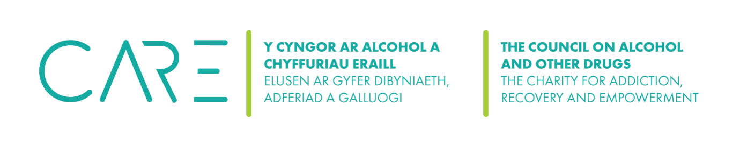
The Council on Alcohol and Other Drugs (CAOD) Financial Management Policy
1.Introduction
1.1 Financial records will be kept so that the charity can: Meet its legal and other obligations, e.g., Charities Act 1992, Inland Revenue, Customs & Excise, and common law. Enable the trustees to be in proper financial control of the small charity. Enable the charity to meet the contractual obligations and requirements of funders.
1.2 The charity will keep formal accounts by QuickBooks
1.3 The financial year will end on 31 March each year.
1.4 Accounts will be drawn up after each financial year within six months of the end of the year and presented to the next Annual General Meeting / Trustees for approval.
1.5 Prior to the start of each financial year, the trustees will approve a budgeted income and expenditure account for the following year.
1.6 A report comparing actual income and expenditure with the budget will be presented to the trustees every three months.
1.7 The AGM will appoint an appropriately qualified auditor/examiner to audit/examine the accounts for presentation to the next AGM.
2. Banking
2.1 The small will bank with METRO Bank; the account name is The Welsh Council on Alcohol and Other Drugs. Separate Accounts for Friends of the Living Room and Cynnal projects.
2.2 The bank mandate (list of people who can sign cheques / authorised signatories on the organisation’s behalf) will always be approved and minuted by the trustees as will all the changes to it.
2.3 The charity requires the bank to provide statements every month and these will be reconciled with QuickBooks at least every three months. The treasurer will be responsible for ensuring that this reconciliation has been done, reporting to trustees.
2.4 The charity will not use any other bank or financial institution or use overdraft facilities or loan without of the agreement of the trustees.
3. Receipts (income)
3.1 All monies received will be recorded promptly in QuickBooks. The charity will maintain files of documentation to back this up.
4. Payments (expenditure) The aim is to ensure that all expenditure is on the charity’s business and is properly authorised and that this can be demonstrated. The latest approved budget provides the authority to spend up to the budgeted expenditure, not beyond it.
4.1 The Treasurer or CEO will be responsible for holding the cheque book (unused and partly used cheque books) which should be kept under lock and key.
4.2 Blank cheques will never be signed.
4.3 The relevant payee's name will always be inserted on the cheque before signature and the cheque stub will always be properly completed.
4.4 No cheques should be signed without original documentation (see below).
5. Payment documentation
5.1 Every payment out of the charity’s bank accounts will be evidenced by an original invoice (never against a supplier's statement or final demand). That original invoice will be retained by the small charity and filed.
5.2 Expenses / allowances. For now, the charity does not operate a refund travel / subsistence expenses.
6. Payments
6.1 Payments are made online by one of the designated signatories
6.2 A cheque can be signed by one of the designated signatories
6.3 The charity’s bank does not operate debit cards
7. Other undertakings
7.1 The charity does not accept liability for any financial commitment unless properly authorised. Any orders placed or undertakings given, the financial consequences of which are likely to exceed in total £10,000, must be authorised and minuted by the trustees. In exceptional circumstances such undertakings can be made with the Chairperson’s approval who will then provide full details to the next meeting of the trustees. (This covers such items as new service contracts, office equipment, purchase, and hire).
7.2 All fundraising and grant applications undertaken on behalf of the organisation will be done in the name of the charity with the approval of the Chair and Treasurer. Applications and successes will be listed in trustee meetings.
8. Other rules
8.1 The small charity will adhere to good practice in relation to its finances at all times, e.g. when relevant it will set up and maintain a fixed asset register stating the date of purchase, cost, serial numbers, and normal location. Additionally, the small charity will maintain a property record of items of significant value, with an appropriate record of their use.

Date | Changes made | Review date

