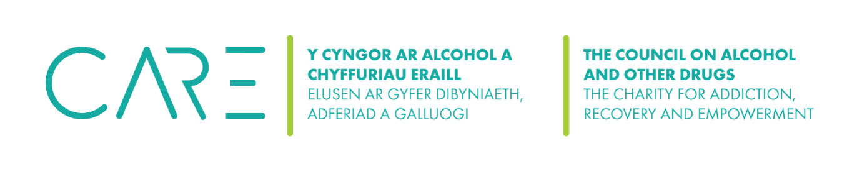

The Council on Alcohol and Other Drugs (CAOD) Mental Health and Wellbeing Policy
- Purpose
The purpose of this policy is for the CAOD to establish, promote and maintain the mental health and wellbeing of all members of staff, and volunteers through workplace practices, and encourage members of staff and volunteers to take responsibility for their own health (physical and mental) and wellbeing.
We believe that the mental health and wellbeing of our members of staff and volunteers is key to the success and sustainability of the charity.
2. Policy Aims

The Council on Alcohol and Other Drugs (CAOD) aims:
- To build and maintain a workplace environment and culture that supports mental health and wellbeing and prevents discrimination (including bullying and harassment).
- To increase employee knowledge and awareness of mental health and wellbeing issues and behaviours.
- To reduce stigma around depression and anxiety in the workplace.
- To facilitate members of staff and volunteers, active participation in a range of initiatives that support mental health and wellbeing.
3. Scope
This policy applies to all members of staff, volunteers (including Trustees) and including contractors.
4. Responsibility
All members of staff and volunteers are encouraged to:
- understand this policy and seek clarification from management where required
- consider this policy while completing work-related duties and at any time while representing the CAOD
- support fellow workers in their awareness of this policy
- support and contribute to the charity’s aim of providing a mentally healthy and supportive environment for all workers.

All employees have a responsibility to:
- take reasonable care of their own mental health and wellbeing, including physical health
- take reasonable care that their actions do not affect the health and safety of other people in the workplace.
Managers have a responsibility to:
- ensure that all workers are made aware of this policy
- actively support and contribute to the implementation of this policy, including its goals
- manage the implementation and review of this policy.
5. Communication
We will ensure that:
- all members of staff and volunteers receive a copy of this policy during the induction process
- this policy is easily accessible by all beneficiaries of the organisation
- members of staff and volunteers are informed when a particular activity aligns with this policy
- members of staff and volunteers are empowered to actively contribute and provide feedback to this policy
- members of staff and volunteers are notified of all changes to this policy.
6. Monitoring and review
We will review this policy 12months after implementation and annually thereafter.
Effectiveness of the policy will be assessed through:
- feedback from workers, the Health and Wellbeing Committee (if applicable), beneficiaries and the trustees.
- review of the policy by the Board of Trustees to determine if objectives have been met and to identify barriers and enablers to ongoing policy implementation.

Date | Changes made | Review date
January 2025 | Policy adopted | January 2026

Wellness at Work Plan 
We have discussed the steps that we may be able to take to support you in the workplace and the things that you will be doing to help maximise your wellbeing. We are recording this discussion in this form which will be stored confidentially. This form is not legally binding but will help us to agree practical steps to support you in work and address your needs.

Your description of how your condition or symptoms affect you and how it impacts on work:

Your description of any triggers or early warning signs we might notice, if you were to become unwell again:

The things we discussed we can do to support and help your wellbeing in work:
Any things you want us to avoid doing:

If your health deteriorated whilst you were still at work or we felt there were early warning signs of a problem, what would we do? Who can we contact?
Please include contact names and numbers:

The steps you are going to take to manage your wellbeing and condition:

Things we have agreed we will do to support you in those efforts:

Signed

Name

Signed by Line Manager

Name

Date

